**To:** The Honorable Harry Dalways, Mayor, City of Urbanville

**From:** Grace Sam, Policy Analyst

**Date:** September 28, 2024

**Subj**: Alternatives for rental subsidy program

Background

Rental rates for apartments and houses have increased significantly over the last several years. A study completed earlier this year indicated that almost half the households living in rental housing in the city spent over 30% of their incomes on rent, and about one-fourth of the households spent more than half their income on rent in 2023. Employers had shared their difficulty in filling jobs as potential employees cannot find affordable housing. Even business and community leaders have called attention to this issue.

Problem Definition

The problem in focus is the lack of affordable housing options in the city, which is measured and defined in terms of the number of households spending over 30% of their income on rent every month.

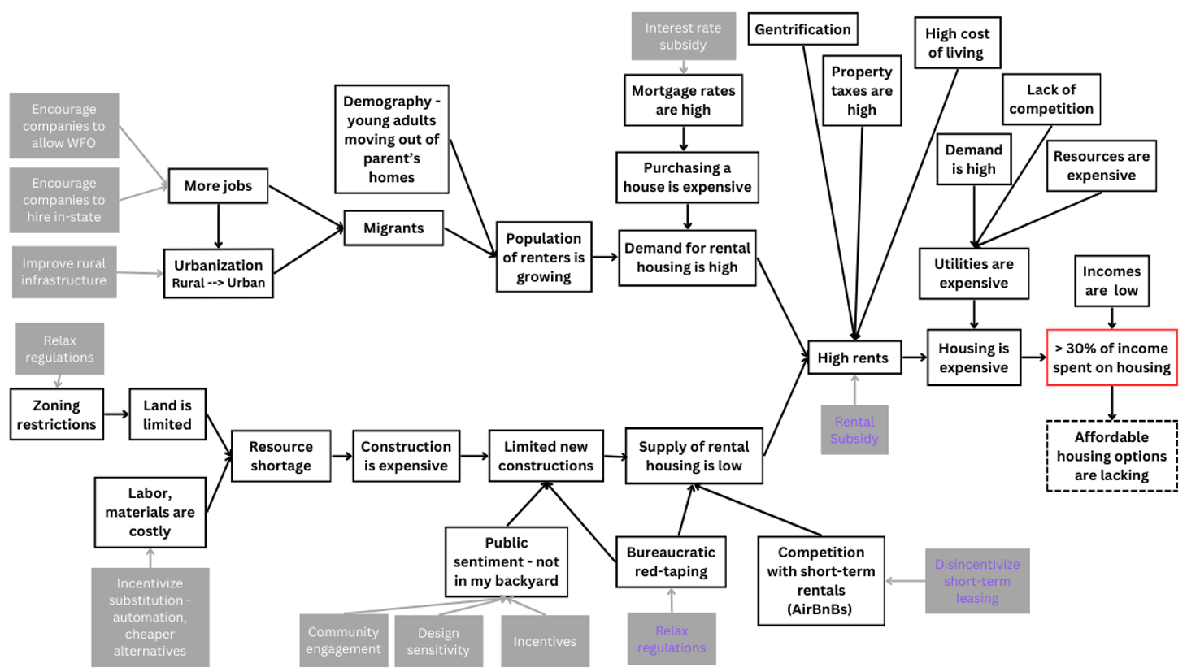

Figure 1 – Causal Model for Lack of Affordable Housing Options in Urbanville. The solid, black-outlined boxes are the factors at play, with the end nodes being the root causes. The boxes in grey are potential policies that can alleviate the affordable housing problem by targeting the linked root cause. A subset of these policies is considered in this memo and are in purple font in the figure.

The causal model in Figure 1 outlines the potential factors (the solid, black-outlined boxes) affecting the issue. The boxes in grey are policy changes that can alleviate the issue via the pathway outlined.

Before scoping the rent subsidy program, the next section will briefly consider two other policy options that hold the potential to alleviate the issue of lack of affordable housing in the city.

Other Policy Options

* Disincentivizing short-term leasing

Short-term leasing options, like AirBnBs, while lucrative for homeowners, take houses off the market, reducing the supply of rentals. This can create a ‘pseudo-shortage’ contributing to high rents, and adversely affects the housing market.

Disincentivizing short-term leasing by imposing higher taxes and licensing fees can increase revenue inflow and make short-term leases expensive. The decrease in demand will incentivize owners to shift these units to long-term rentals. Restricting the number of house available for short-term leases through zoning laws can also increase the supply of rentals. Free hand of market dictates that the increase in supply of rentals in the city will have a downward pull on the rental prices, reducing the proportion of income that households spend on rent, and make housing more affordable in the city.

Short-term leasing affects tourism, and short-term stints, like internships and contractual jobs. Making this option costly can negatively affect tourism income and make short-term housing difficult for those looking for temporary engagement in the city.

* Reducing bureaucratic red tapes that make renting expensive

Overly complex tenancy regulation can make renting difficult for owners. Expediting approval timelines, simplifying regulation, and lower compliance costs can incentivize landlords to rent. The increased supply of rental options will bring down the price of rentals in the city.

An unintended impact of this policy would be that owners for whom the regulations were needed the most – say those who maintain their house poorly and were likely to not be approved for renting – would respond to this policy more, risking the health and safety of tenants and community.

Increasing the supply of rental options alone cannot ensure that housing is affordable in the short run. These in combination with a rental subsidy can work towards making rental housing affordable in the city over time.

The third policy alternative is to give households rental subsidies, which directly targets the issue by reducing the monthly expenditure on rent by way of provided subsidy. The following section outlines in detail three subsidy options and their possible impacts.

Rental Subsidy Program – Details

The underlying objective of these programs is to make housing affordable in the city by reducing the proportion of income spent on rent to make Urbanville a competitive city of choice for its workers and to ease the burden on its residents. Given budgetary constraints, the program alternative could target the ‘neediest’ segments through eligibility criteria or through the size of the subsidy given.

The following section will outline three alternatives for the rental subsidy program. For each alternative, the program details, models to estimate the impact, and potential undesirable effects would be considered.

Alternative 1- Discretionary program ($20 million benefit budget) giving rental assistance up to $5000 to eligible households

* Program:

Alternative 1 is a discretionary program with a maximum budget of $20 million for benefit spending. The amount given in rental assistance is the minimum of (Rent - 0.3 * income, $5000), i.e. an eligible household can get rental subsidy equal to the extent their rent is more than 30% of their income, up to $5000.

* Eligibility criteria:

All households with annual household income less than $50,000, who pay over 30% of their income in rent and where the oldest member is between 25-64 years old are eligible to apply.

As the column [9] in Figure 2 illustrates, percentage of income spent on rent drops because of the program, though rent even after subsidy continues to be over 30% of income (column [8]).

Figure 2 – Illustrating Alternative 1 – Discretionary Program with program spending capped at $20 million. If Rent > 30% of Income, Assistance = MIN (Rent - 0.3 * income, $5000)

To prevent these programs from affecting rents and housing decisions, the subsidy will only be available for the coming year. The idea is to give short-term relief to the residents through this program, while longer-term solutions, like construction and provision of affordable housing options by the government, and changes in taxes and fees aimed to influence the supply of rentals are planned and implemented.

* Impact on government spending:

The model in Figure 3 illustrates the relation between the program and the budget spent on it.

Figure 3 – Illustrating relation between Alternative 1 and City budget. Since this is a discretionary program, the arrows, in blue, are reversed, as the budget allocated determines the #recipients and possibly the grant per recipient.

Here, *Benefit spending = Grant per recipient * #recipients,*

*#interested and eligible = #population * %eligible * participation rate1,*

*#recipients = #interested and eligible if funds last, else first-cum-first serve, until funds remain,*

*Grant per recipient = MIN($5000, Rent-0.3*income),*

*Government share of the cost is $5000 maximum,*

*Program spending = Benefit Spending + Admin Cost*

The administrative costs of implementing the program would be high as both recent rental and income data is needed to determine eligibility. The estimates depend on the assumed values of administration cost, participation rate, the actual population renting, and the distribution of rent and incomes of households.

* Impact on households:

To understand how the program works to alleviate the ‘rent burden’ (defined as the extent to which rent exceeds 30% of income), the model in Figure 4 illustrates the relation between the program and its impact on housing affordability.

Here, *Need = Rent – 0.3*Income,*

*Rental subsidy amount = Assistance = MIN (Need, $5000),*

*% Need Met = Rental subsidy amount/Rent*

The conservative estimate for the number of households that could be in need for assistance is approximately 20,000. If all households claim the maximum amount, i.e. $5000, the program can assist 4000 households. These are conservative estimates, and the program could be assisting more households as aid amounts would be lower than $5000 for households where the difference between rent and 30% of household income is less than $5000.

Figure 4 – Illustrating relation between Alternative 1 and impact on rent burden. Since this is a discretionary program, the arrows, in blue, are reversed, as the program cost allocated can affect the eligibility criteria and possibly the benefit amount per recipient.

The sheet ‘Impact-alternative1’ in the spreadsheet illustrates scenarios and corresponding estimates of program’s impact.

* Unintended impact:

An undesirable impact of the model could be that the landlords increase the rent to the extent that residents remain eligible for the program so that their rental income increases, without equivalent rent increase for the tenants. This is possible because landlords have complete information to do these calculations – the program details are public knowledge, and tenants’ income information is required as part of the lease signing. Another unintended and more serious impact of the model would be because of its first-come-first-serve nature. The poorest households, for whom the rental burden is the most serious as it dangerously limits their spending on other necessities, like food, health, and medication, possibly would find it hard to find the time to get the necessary documents required to register for the program, and as a result would miss benefiting from it.

Alternative 2 – Uniform absolute rental subsidy of $3000 for eligible households

* Program:

Under this program, all eligible households in the city get $3000 in rental subsidy. Independently of this, the government imposes an annual one-time flat fee of $250 that all residential property *owners* in the city must pay.

* Eligibility criteria:

All households earning less than $35,000 income, where the age of the oldest member is between 25-64 years, and who have paid over 30% of their income in rent for the last 6 months, and their lease and income condition at the time of program announcement shows continued ‘rental burden’ (rent is more than 30% of income) are eligible.

The administrative costs of implementing the program would be high as both rental and income data is needed to determine eligibility. As with Alternative 1, the program will be available only for a year to prevent landlords and renters from responding to the program by changing rents or shifting houses to circumvent the policy.

Figure 5 – Illustrating Alternative 2. Assistance = $3000 if eligible.

As the column [11] in Figure 5 illustrates, percentage of income spent on rent drops because of the program, though rent even after subsidy continues to be exorbitant proportion of income (column [10]).

* Impact on government spending:

The model in Figure 6 illustrates the relation between the program and the money spent on it.

Here, *Benefit spending = Grant per recipient * #recipients,*

*#recipients = #population * %eligible * participation rate,*

*#eligible = #population * %eligible1*

*Grant per recipient = $3000,*

*Government share of the cost set at $3000,*

*Program spending = Benefit Spending + Admin Cost*

*Realized program expense = Total expense = Program spending – Revenue from the additional one-time fee on property owners*

The cost estimates depend on administration cost, participation rate, the actual population renting, and the distribution of rent and incomes of households.

Figure 6 – Illustrating relation between Alternative 2 and City budget.

* Impact on households:

To understand how the program works to alleviate the ‘rent burden’ (defined as the extent to which rent exceeds 30% of income), the model in Figure 7 illustrates the relation between the program and its impact on housing affordability.

Here, *Need = Rent – 0.3*Income,*

*Rental subsidy amount = Assistance = $3000,*

*% Need Met = Rental subsidy amount/Rent*

Figure 7 – Illustrating relation between Alternative 2 and impact on rent burden.

The conservative estimate for the number of households that could be in need for assistance is approximately 16,000. If all eligible households claim the subsidy (participation rate 100%), the program cost is $60 million according to the model. The additional property tax instituted for the year can balance the program cost to about $35 million. These are conservative estimates, and the program costs could be lower. The sheet ‘Impact-alternative2’ in the spreadsheet illustrates scenarios and corresponding estimates of program’s impact.

* Unintended impact:

An unintended impact of this program could be that people try to move into lowest rent options possible to make the most of the program. This will crowd out the cheaper options for those who need it the most, making housing more expensive in the city. This can increase the number of eligible households for the program, increasing the program cost. The explicit one-year tenure of the program is expected to deter this tendency at least to some extent.

Alternative 3 – Maximal rental support option for eligible households

* Program:

Alternative 3 is the maximal support option, where the government pays the difference between rent and 30% of income.

* Eligibility criteria:

All households with income less than $75,000, and where the oldest member of the household is between 25-64 years old are eligible for the program.

The program will subsidize households for the rent amount over 30% of their income, but up to a maximum. The maximum assistance amount is defined at a household size level using $1000 as the reference monthly rent amount for an individual household. The monthly rent amount for households with more people is calculated basis household size. The table below indicates the maximum assistance for each household size.

Figure 8 – Maximum assistance per household size level under Alternative 3.

The administrative costs of implementing the program would be high as both rental and income data is needed to determine eligibility. As with the other two alternatives, the program will be available only for a year to prevent landlords and renters from responding to the program by changing rents or shifting houses to circumvent the policy.

As the column [11] in Figure 9 illustrates, percentage of income spent on rent drops because of the program and rent after subsidy is in the desirable 30% range in most cases (column [10]).

Figure 9 – Illustrating Alternative 3. If Rent > 30% of Income, Assistance = MIN(Rent-0.3*Income, Household level maximum)

* Impact on government spending:

The model in Figure 10 illustrates the relation between the program and the budget spent on it.

Here, *Benefit spending = Grant per recipient * #recipients* (though grant each recipient receives is not uniform)*,*

*#recipients = #population * %eligible * participation rate,*

*#eligible = #population * %eligible 1*

*Grant per recipient = MIN(Max assistance for HH size, Rent-0.3*income) if spending over 30% on income,*

*Government share of the cost has a maximum for each household size,*

*Program spending = Benefit Spending + Admin Cost*

The cost estimates depend on administration cost, participation rate, the actual population renting, and the distribution of rent, household size, and incomes of households.

Figure 10 – Illustrating relation between Alternative 3 and City budget.

* Impact on households:

As for Alternative 2, to understand how the program works to alleviate the ‘rent burden’ (defined as the extent to which rent exceeds 30% of income), the model in Figure 7 illustrates the relation between the program and its impact on housing affordability.

Here, *Need = Rent – 0.3*Income,*

*Rental subsidy amount = If Rent > 30% of Income, Assistance = MIN(Rent-0.3*Income, Household level maximum assistance),*

*% Need Met = Rental subsidy amount/Rent*

The conservative estimate for the number of households that could be in need for assistance is approximately 27,000. If all eligible households claim the subsidy (participation rate 100%), the benefit spending estimate is $225 million according to the model. These are conservative estimates, and the program costs could be lower. The sheet ‘Impact-alternative3’ in the spreadsheet illustrates scenarios and corresponding estimates of program’s impact.

An alternate version of the program can restrict eligibility to household income less than $35,000 to lower program cost. The sheet ‘Impact-alternative3_35k filter’ in the spreadsheet illustrates scenarios and corresponding estimates of program’s impact.

* Unintended impact:

Figure 11 – Illustrating unintended incentive in Alternative 3 to increase household size

An unintended impact of the program could be that that it might encourage residents to partner and increase household size. As the snippet of the table below shows, at the same income level, assistance increases with household size. For example, 3 unemployed people can move in with an employed person with $30,000 income.

Evaluating impacts of the three alternatives

The cost, number of households benefited, and the extent of benefit given depends on attributes of the multiple stakeholders and systems involved and affected by the program.

On part of the government, the expense of administering the program, and the funds available are crucial factors determining program eligibility, extent, and impact. On part of the residents renting house in the city, the participation rate, the income distribution and rents being paid across income classes, would determine need, program eligibility, and the proportion of the need that a program can meet.

The only available data on residents’ rents and incomes, give 90% confidence interval estimates for the number of residents in different income and rent buckets. Participation rate and administration costs are unknow and are assumed here. The estimates are summarized in the sheet titled ‘Alternatives Evaluation’ of the spreadsheet. These heuristic estimates should only be used for the upcoming year and should be updated as soon as new data is available.

The performance of the different alternatives against the objectives is summarized in the matrix in Figure 12. Details of the calculation are available in the sheet titled ‘DM’ in the spreadsheet.

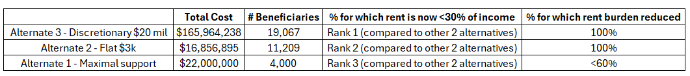 Figure 12 – Comparing performance of alternatives on cost of the program, #beneficiaries, relative performance on the extent of rent burden reduced

Recommendation

As the matrix in Figure 12 illustrates, Alternative 3 gives the maximal relief to the residents but is very expensive. The additional property tax imposed with alternative 2 illustrates that costs can be set off with new streams of revenue. A combination of Alternative 3 with a one-time tax *(job revival tax)* on companies to offset the program cost will most effective and is plausible as companies can be incentivized with the new employees that will accept the jobs with lower rent that the imposed tax will enable.

***Footnotes:***

1. Instead of using % eligible, in the excel we directly calculate #potential_eligible basis the data available. This is done using the excel sheet ‘Conservative est. rent%ofincom’ where this is explained more.

***General notes:***

* For each of the alternatives, the assistance will be at a ‘house’ level, i.e. rent assistance is given out once per house. So, unrelated residents at the same address cannot claim assistance individually. Income is also calculated at ‘house’ level, i.e. if program has eligibility thresholds on income, the income is calculated as the total income earned by all the residents on the lease. This is to avoid multiple claims for same rental property. To avoid the program from influencing (re)housing decisions, the program will require last 3 months’ pay slips for residential proof. Since the program is available for only a year, any longer-term effect on housing decision is not expected because of this program.
* Older population (>65-year-olds) are not included in alternatives because they can be supported through alternate programs meant for senior citizens. Budget constraints required this filter.

**------ THE END -----**